EXAM 2 JAMES TOROK

PROBLEM 1
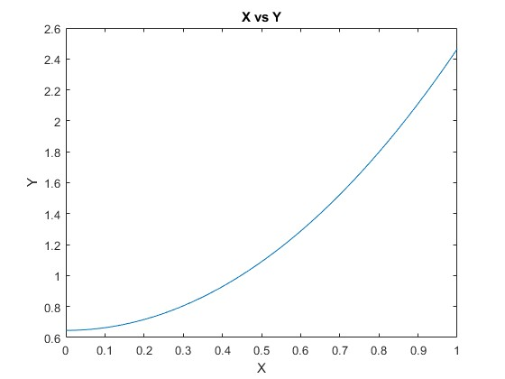
PROBLEM 2
OUTPUT:
** DIRECT WAY **
x(1) = 1.000
x(2) = 2.000
x(3) = 3.000
****************
** GAUSS ELIM **
x(1) = 1.000
x(2) = 2.000
x(3) = 3.000
****************

